Lab Experiment: 3

Title: Inspection of Voltage Variation with Light Dependent Resistor (LDR) using Arduino (Analog Sensor Interfacing)
Course title: IOT Laboratory

Course code: CSE-460
4th Year 1st Semester Examination 2025

Date of Submission: 22/02/2026

Submitted to-

Dr. Md. Ezharul Islam, B.SC.(JU), M.ENGG.(JAPAN), PHD(JAPAN)
Professor
Department of Computer Science and Engineering
Jahangirnagar University

&

Samsun Nahar Khandakar
Assistant Professor
Department of Computer Science and Engineering
Jahangirnagar University
Savar, Dhaka-1342

Class Roll | Exam Roll | Name
383 | 210903 | Abdullah Nazmus-Sakib
379 | 210899 | Shah Sultan
391 | 210911 | Md Khaled Mahmud

📘 1. Title Inspection of Voltage Variation with Light Dependent Resistor (LDR) using Arduino

🎯 2. Objective
- To interface an analog sensor (LDR) with Arduino
- To observe voltage variation with changing light intensity
- To convert analog input into digital output using ADC
- To control LED brightness based on light level

🧰 3. Components Required

Component | Quantity
Arduino Uno | 1
LDR (Light Dependent Resistor) | 1
LED | 1
Resistor (10 kΩ for LDR) | 1
Resistor (220–330 Ω for LED) | 1
Jumper wires | As required
Breadboard | 1
USB cable | 1

🔌 4. Circuit Connection

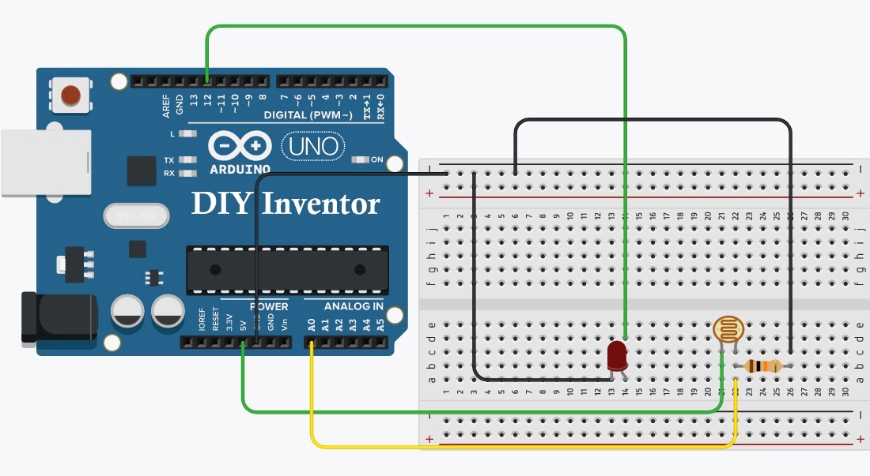

🔹 LDR Voltage Divider
- One terminal of LDR → 5V
- Other terminal of LDR → Analog Pin A0
- 10 kΩ resistor from A0 → GND
👉 This creates a voltage divider whose output depends on light intensity.

🔹 LED Connection
- LED Anode (+) → Digital Pin 9 (PWM)
- LED Cathode (–) → GND through 220–330 Ω resistor

💻 5. Program (Arduino Code)
const int analogInPin = A0; // LDR input
const int analogOutPin = 9; // LED output (PWM)

int sensorValue = 0;
int outputValue = 0;

void setup() {
Serial.begin(9600);
}

void loop() {
sensorValue = analogRead(analogInPin);
outputValue = map(sensorValue, 0, 1023, 0, 255);
analogWrite(analogOutPin, outputValue);

Serial.print("sensor = ");
Serial.print(sensorValue);
Serial.print("\t output = ");
Serial.println(outputValue);

delay(1000);
}

⚙️ 6. Working Principle
- LDR resistance changes with light intensity
  - 🔆 More light → Lower resistance
  - 🌑 Less light → Higher resistance
- The voltage divider converts resistance change into voltage change
- Arduino reads this voltage via Analog-to-Digital Converter (ADC)
- ADC converts voltage into values from 0–1023
- These values are mapped to 0–255 for PWM output
- PWM signal controls LED brightness

👉 Result: LED brightness varies according to surrounding light.

▶️ 7. Procedure
- Collect all required components
- Build the circuit according to the diagram
- Connect Arduino to computer via USB
- Open Arduino IDE
- Write or paste the code
- Select correct Board and Port
- Upload the program
- Open Serial Monitor to observe sensor readings
- Change light conditions (cover/uncover LDR) and observe LED brightness

📊 8. Observation
- When light intensity increased → Sensor value changed → LED brightness changed
- Serial Monitor displayed corresponding analog readings
- System responded smoothly to light variation

📈 9. Result
The experiment successfully demonstrated voltage variation with light intensity using an LDR and analog interfacing with Arduino. LED brightness was controlled according to ambient light conditions.

🧠 10. Applications
- Automatic street lighting systems
- Smart home lighting
- Light meters
- Solar tracking systems
- Security systems
- IoT environmental monitoring

⚠️ 11. Precautions
- Use correct resistor values
- Ensure proper polarity of LED
- Avoid loose connections
- Do not short 5V to GND
- Check analog pin connection carefully

🏁 12. Conclusion
This experiment provided practical understanding of analog sensor interfacing in IoT systems. It demonstrated how environmental light can be measured using an LDR and used to control devices automatically. The knowledge gained is fundamental for building smart automation and sensing systems.

